Violation of Cultural Heritage Rights and Deficient Human Rights Education in Local Governance
Gasilska Street 4, Pijava Gorica, Municipality of Škofljica, Slovenia
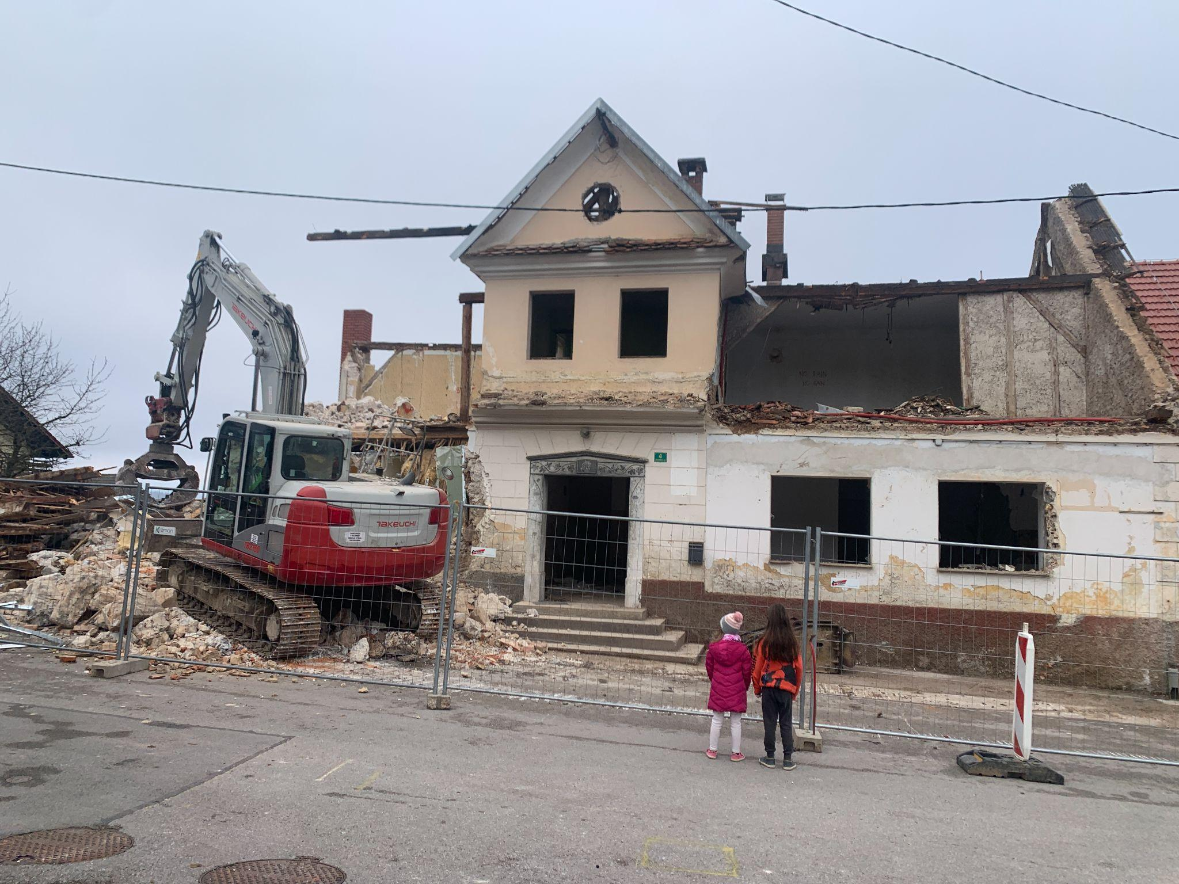
The attached photograph documents a case from the Municipality of Škofljica, where the local authorities decided to demolish a site officially designated as protected cultural heritage against the expressed will of a civil initiative representing the affected Slovenian indigenous communities.
Sufficient signatures were collected in a timely manner in accordance with the municipality’s statute, and transparent communication was organized in a timely way by the civil initiative to promote dialogue, in order to prevent the demolition of a house that is an important part of the overall cultural heritage of the town’s old square. The house, located at Gasilka Street 4, was at least 150 years old, built shortly after the establishment of the Austro-Hungarian Empire, with a portal dated 1879, and has since survived all political regimes and vested interests. It withstood the Ljubljana earthquake of April 14, 1895, survived both World Wars, and served as the mayor’s residence as well as a home for generations of owners and tenants. Over the years, it also functioned as an inn, a kiosk, a primary school, and a shop—in short, it has been the heart of the community. Despite public opposition and efforts by community members to engage in dialogue, the decision was implemented without meaningful participation, consultation, or consent, raising serious concerns regarding compliance with international standards on cultural rights, heritage protection, and public participation in decision-making processes. A civil legal process was initiated on 11 December 2025 by a civil initiative representing the affected community. Despite this, the municipality ignored the civil initiative and proceeded with the demolition between 17 December 2025 and 29 December 2025. We assess that this situation is partly the result of a structural deficit in education on human rights within the public schooling system (a curriculum that exists in theory, but without trained professionals who understand how human rights are applied in practice and administration).
Many public officials and decision-makers have not received adequate education on human rights, international legal obligations, or mechanisms for their implementation. As a result, public policies are often developed and implemented without sufficient awareness of the State’s international commitments. An additional challenge lies in the inadequate, inconsistent, or ambiguous interpretation of international human rights standards, often linked to poor or imprecise translations of key international instruments.
This has direct consequences for the design of political programmes, legislation, and educational curricula to which children are exposed in public schools. Slovenia is therefore facing a systemic failure to implement international standards related to the right to education, cultural rights, and participation, particularly affecting Slovenian families with children. Without comprehensive reforms that include culturally respectful curricula, meaningful participation of affected people, and systematic human rights education for both public officials and students, integration will remain coercive rather than genuinely inclusive.
This case demonstrates that the public authority, acting also as the founder of public schools (e.g., Osnovna Šola Škofljica, which operates under and implements the national curriculum under the Ministry of Public Schooling Education’s oversight), bears a responsibility to ensure that the curriculum adequately raises awareness among children, parents, and the local community about the importance of protecting local cultural heritage. In relation to the destruction of cultural heritage, it appears that even critical reflection is discouraged, and that neither open dialogue nor roundtable discussions are permitted. This reflects a visible consequence of the way education (In Slovenia, access is restricted to the public schooling system, with no equivalent alternatives formally recognized outside state-funded institutions.) and upbringing have been structured and practiced to date, where critical thinking and public debate have not been sufficiently encouraged.
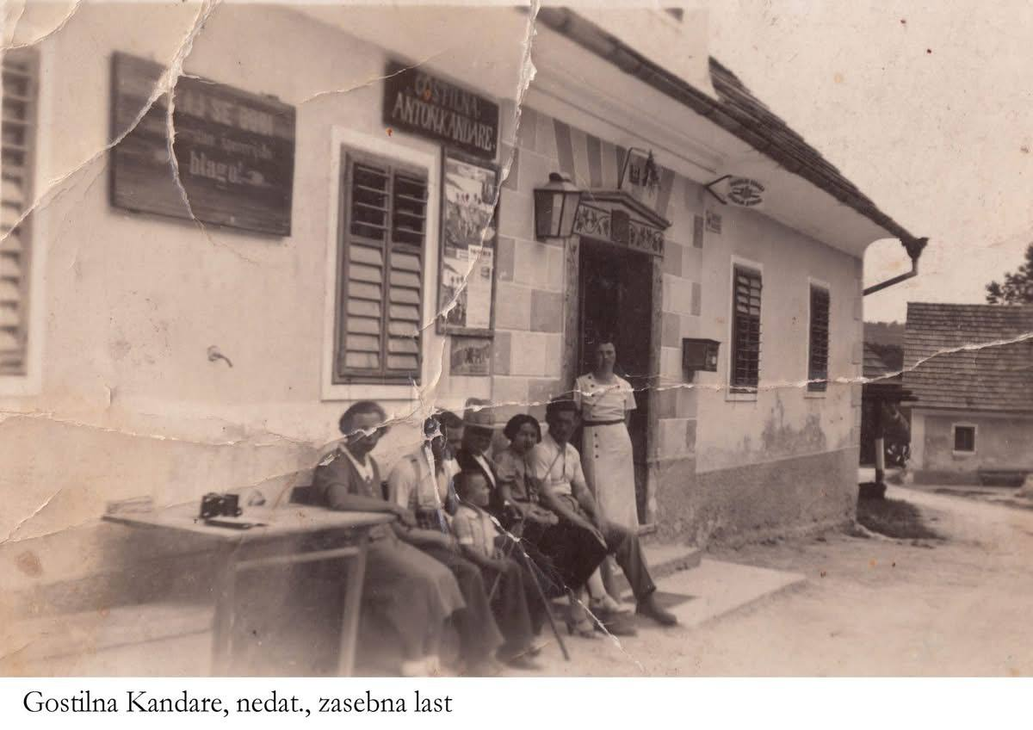
Failure to do so directly contributes to the erosion of the cultural heritage of Indigenous and autochthonous students within the public schooling system. Public authorities have not sufficiently integrated the cultural heritage of Slovenians into the national curriculum, nor have they ensured that current students receive an updated and inclusive account of the region’s full historical and cultural context. By neglecting these obligations, the authorities effectively signal that the culture of these children is considered undervalued and undeserving of respect. This approach is directly linked to the degradation of the intangible cultural heritage of the affected communities. Furthermore, local communities themselves bear a role in actively participating and safeguarding their cultural heritage, in line with both national law and internationally recognized standards. Instead of respectfully acknowledging the messenger of ancestral knowledge—a free and independent researcher and historian who is also a bearer of local knowledge from this region—the governing authorities, including the municipality and its mayors, chose to turn away for political reasons. This occurred despite the fact that the community possesses the rare and valuable asset of a living historical researcher, and that there are still people residing in the area who are direct witnesses to historical events, as well as collectors and custodians of cultural heritage, including tools and machinery. These individuals could clearly demonstrate that they are rights holders of this specific culture.
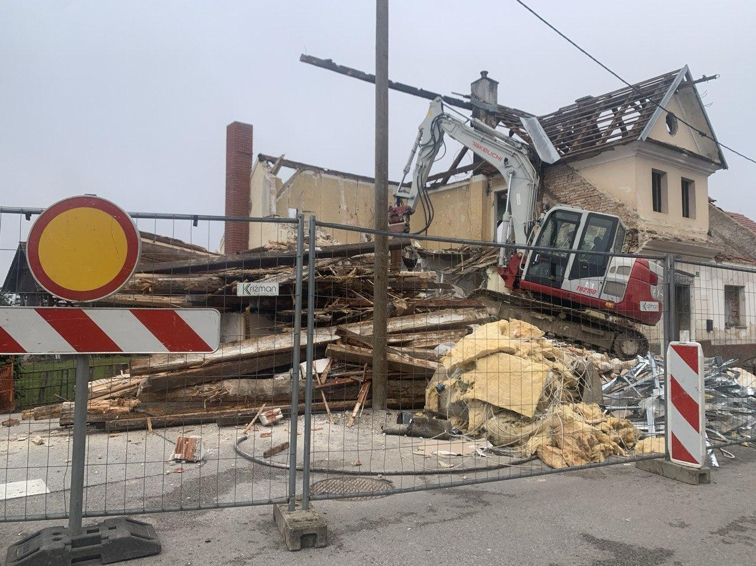
The deliberate disregard of such living knowledge holders constitutes a serious failure to recognize and protect intangible cultural heritage and the rights of the communities that sustain it. This conduct constitutes a failure to comply with international human rights obligations, including those arising from the UNESCO Convention for the Safeguarding of the Intangible Cultural Heritage, as well as for example Articles 15 of the International Covenant on Economic, Social and Cultural Rights and the International Covenant on Civil and Political Rights.
By disregarding living knowledge holders, local historians, and community members who are direct witnesses and custodians of cultural heritage, the authorities failed to recognize the affected individuals as rights holders and themselves as duty bearers. This omission undermines the protection of intangible cultural heritage and violates the principles of participation, cultural self-identification, and respect for cultural diversity.
We emphasize that this situation is not an isolated incident, but an inseparable consequence of public school curricula that systematically exclude the cultural heritage of the Slovenian people. The absence of meaningful education on local and national cultural heritage within the public schooling system contributes directly to institutional attitudes that devalue living culture and normalize its erasure in administrative and political decision-making.

Slovenske novice daily newspaper, issue published in December 2025
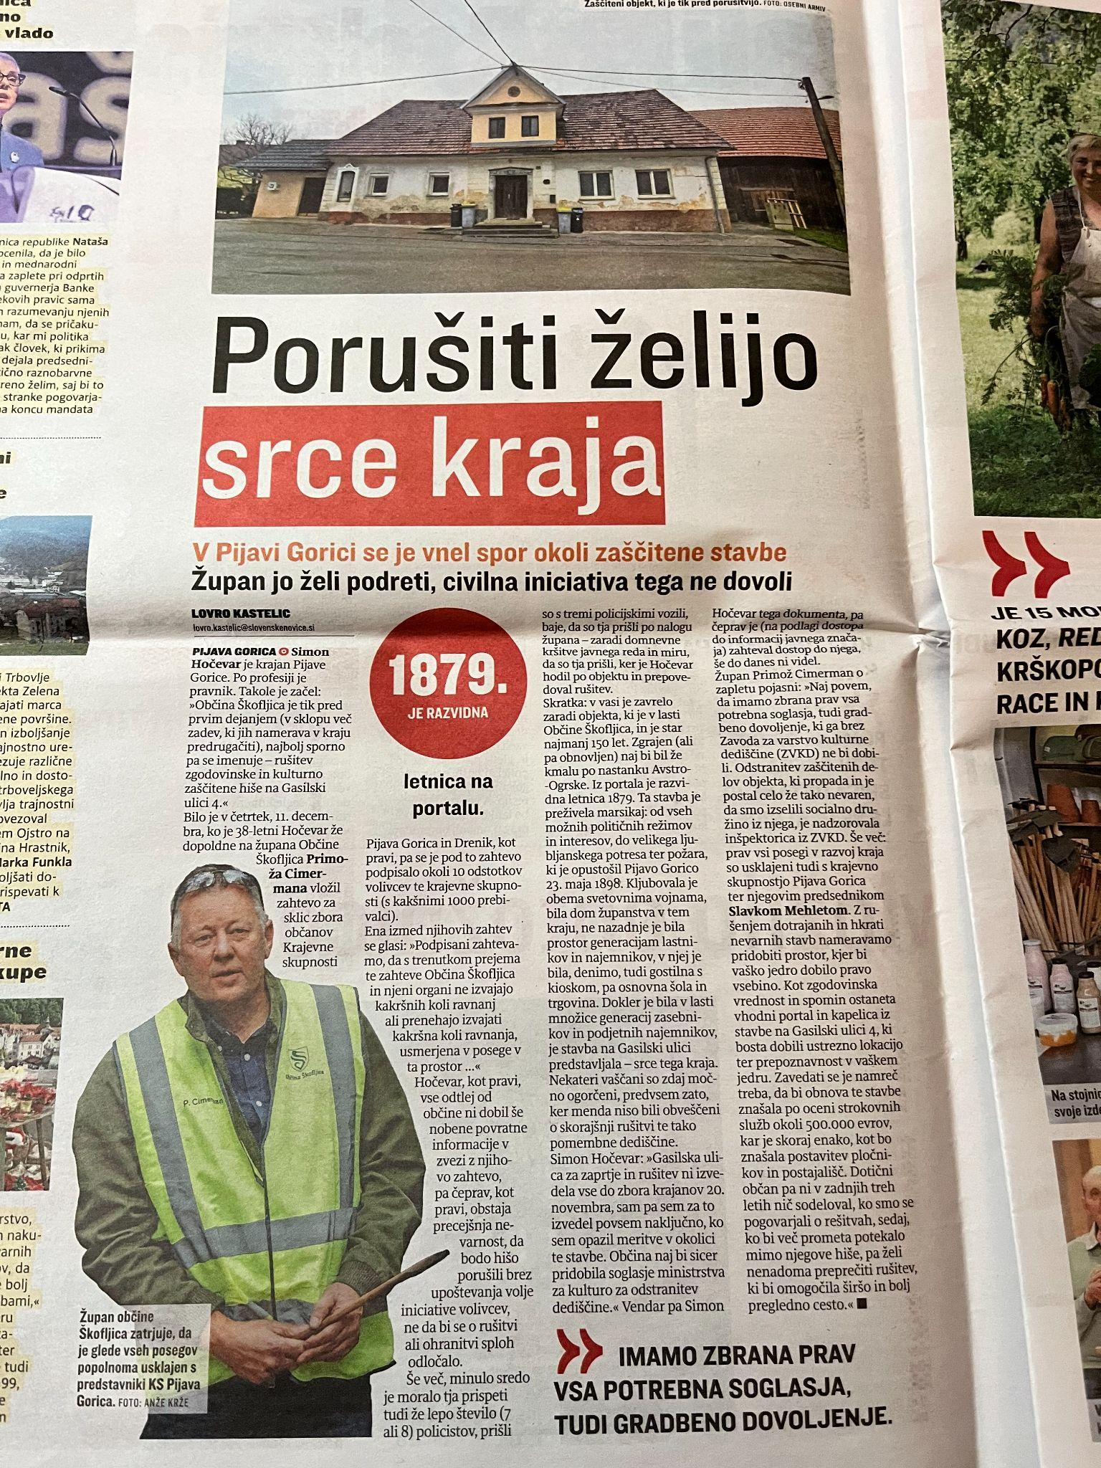

Civic and Homeland Culture and Ethics is a subject taught in the 7th and 8th grades of public primary schooling education. In practice, however, it largely involves memorization of predefined content that has little relevance to contemporary life and lacks direct practical application.

