Annex 1 - Misalignment of Slovenia’s Definition of Primary Education with UNESCO’s ISCED Standards and CRC Obligations

Definition of primary education in the eyes of the State Slovenia is different than in the UNESCO's ISCED table. ISCED table considers just level 1 is primary education, which is learning how to write, read, calculate and know human rights. In these ages it’s advisable to learn at least some degree of digital literacy. However, the State of Slovenia considers 9 years of “primary school education” which is understood as compulsory for the child and primary is used so it can stay compulsory. Here 3 things are completely wrong and are in violation of CRC:
- The child is forced or compelled to master the state curriculum.
- The term “primary school education” (Slovenian = osnovnošolsko izobraževanje) is limited to school and as such, the children even in home education are forced to be enrolled into public school, doing exams in the school with the teachers never known to them and the parent who actually teaches the child is not allowed to participate in oral questioning/research presentation (even if the child wants this).
- The term “primary school education” is used for levels of knowledge ISCED1, ISCED2 and part ISCED3, where the State prescribes the curriculum for the child, without the child. For example, only 2-3 extra subjects can be taken at 7th, 8th and 9th class, in addition to the 11-13 compulsory subjects, regardless if the child is interested in them or not.
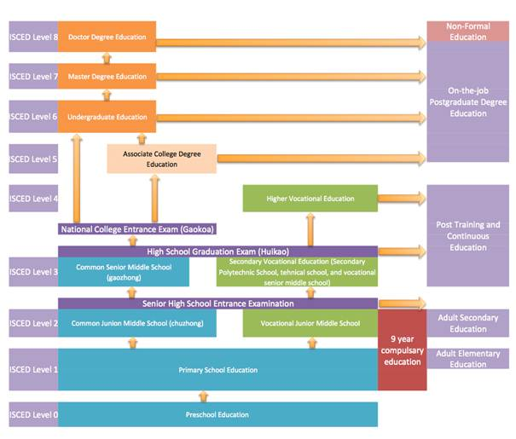
We see problematic also that ISCED1 and ISCED2 are considered as compulsory education - where the State then imposes the state curriculum on the child. However, if the proper interpretation of the word compulsory would be used, like it was intended from one of the drafters of the Declaration of Human Rights M. R. Cassin from France “no one (neither the State, nor the family) could prevent the child from receiving elementary education and that the idea of coercion was in no way implied.”, then this compulsory wouldn’t pose any problem, because it would be better for the child, that his rights are guaranteed to the higher levels of education as just primary.
Here is the table from the compulsory public curriculum on the child: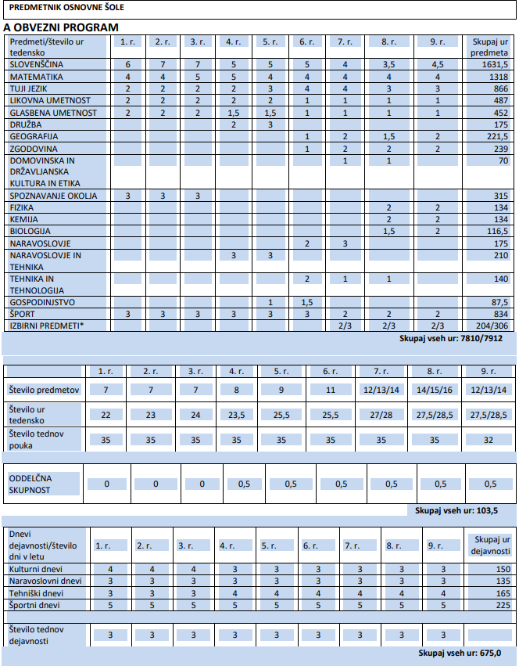
Better graphic presentation is visible in Annex 4, tab: Levels of education.
It is also important to emphasise that children are required to participate in national standardised assessments, which the State uses as a primary instrument for measuring the quality of education. Rather than evaluating whether children’s rights are respected within the education system, the State assesses educational quality predominantly through children’s performance and scores on these assessments.
According to reports from children, participation in these assessments is mandatory and inflexible. Children are not allowed to postpone or opt for alternative forms of assessment even when they experience illness, menstrual pain, psychological distress or a lack of readiness. Some children report that they do not wish to participate in these assessments; nevertheless, their future educational pathways are significantly influenced by the results of national assessments conducted in grades 3, 6 and 9.
These assessments are cumulative in nature and largely require children to memorise and reproduce content acquired over several years. This approach places disproportionate pressure on children and fails to take into account individual circumstances, well-being and developmental differences. As a result, children’s rights to be heard, to have their views taken seriously, and to be treated with dignity are undermined.
Consequences of Slovenia’s Misclassification of Primary Education and the Resulting Pressure on Children
The consequences of Slovenia’s misinterpretation and extension of “primary education” are increasingly visible in children’s mental health. In April 2025, an 8th-grade student at Osnovna Šola Brežice died by suicide. This event has been widely reported in local media and has sparked public concern regarding the mental health of children and adolescents within school environments.
The case highlights several systemic challenges: healthcare professionals and pediatricians in Slovenia lack tools and frameworks to assess the impact of the national school curriculum on children’s mental health, particularly how academic pressures, grading systems, and pedagogical approaches contribute to stress, anxiety, or emotional distress. As a result, when children present with emotional or psychosomatic symptoms, responsibility is often defaulted entirely onto parents, rather than acknowledging structural and curricular factors within the education system that may significantly influence well-being. There are no national statistics about this.
This situation raises concerns regarding Slovenia’s compliance with Articles 3, 6, 24, 28 and 29 of the Convention on the Rights of the Child.

Specific issue for children whose mother tongue education is Slovenian – natural speakers of the language and thus promoting linguistic and cultural diversity and multilingualism
Children whose mother tongue education is Slovenian, arising naturally from their heritage as Slovene indigenous people, and being natural carriers of the language, are not provided with adequate alternative pathways by the State to access an adequate educational attainment. For these children, institutionalized early education is not strictly necessary, as foundational learning can take place at home with their parents (private homeschooling), in line with the child’s natural linguistic environment. While Article 54 of the Slovenian Constitution guarantees the right of parents to direct the upbringing and education of their children, the State has failed to respect the principles outlined by UNESCO regarding mother tongue education. According to UNESCO:
“The mother tongue is the language first learned by the child at home or in the family, and usually the language used most often in early childhood. Instruction in the mother tongue improves learning outcomes and supports cognitive, linguistic, and cultural development.”
Due to misalignment with UNESCO terminology and standards, the realization of the right to learn in the mother tongue in Slovenia has not yet been achieved after more than 30 years. The State has not provided children whose mother tongue is Slovenian with alternative, flexible means to peacefully acquire primary adequate educational attainment outside of the public funded schooling system (all children have to go to 9 year public funded system), despite this being consistent with both international guidance and constitutional parental rights. Mother tongue is essential for cognitive development, literacy, and learning other languages, as well as for preserving cultural identity. In Slovenia, many Slovenian dialects have been lost or marginalized, largely because all children are required to learn standard Slovenian in publicly funded schools. It is therefore crucial to establish a framework for Slovenian parents that respects their linguistic culture, heritage, and traditions, allowing children to maintain their natural language environment while still accessing primary education. Such measures would align with UNESCO guidance on mother tongue education and the rights of parents under the Slovenian Constitution (Article 54) to direct the upbringing and education of their children.

UN ECOSOC, Commission on Human Rights: Third Session, Summary Record of the Sixty-Eighth Meeting, New York, 14 June 1948, p. 3; E/CN.4/SR.68,https://undocs.org/en/E/CN.4/SR.68
https://www.unesco.org/en/articles/international-mother-language-day-why-multilingual-education-key-intergenerational-learning
https://www.nadlani.si/novice/brezice-v-solzah-ucenka-8-razreda-si-je-vzela-zivljenje-odzvala-se-je-tudi-sola/

