From: Sylvie Crawford, Michigan, USA

Submission to the UN Special Rapporteur on the Right to Education

Subject: Curriculum, pedagogy, and assessment at the service of the right to education

Framing note

Following the framing proposed by author Je'anna Clements, this submission treats curriculum, pedagogy, and assessment as optional mechanisms through which the right to education can be realised, rather than as its substantive definition.
More specifically, this submission is based on principles and practices of Self-Directed Education (SDE), which is an educational approach grounded in children’s human rights, learner agency, and democratic participation within a supportive community. In SDE settings, the learners actively participate in shaping the content, pace, methods, and evaluation of their own learning, with appropriate support from adults. SDE is practiced in many countries and within diverse cultural and socio-economic contexts, including in public, private, community-based, and home-based education settings. It prioritizes the best interests of the child, the right to be heard, the right to rest, play, participate in cultural life and the arts, and the right to an education that fully develops the child’s personality, talents and abilities, as articulated in the Convention on the Rights of the Child.
For the purpose of this submission, I will focus on observations from my own household and community learning environment, in which children of all ages are supported by adults who act as facilitators and mentors rather than instructors, providing access to resources, emotional support, and opportunities for engagement with the wider community. Learning takes place at home, in the wider community, online, and in natural environments, and is aligned with the children’s evolving interests, developmental stages, and well-being.

I. Conception, design and implementation of the curriculum

(a) Learning needs, contemporary challenges, and life skills

Article 29 of the CRC establishes that education must be directed to the development of the child’s personality, talents, and mental and physical abilities to their fullest potential, as well as preparation for responsible life in a free society. The Committee has clarified that this requires education to be child-centered, empowering, and relevant to real-life challenges.
In SDE contexts, curriculum emerges from learners’ interests, questions, and engagement with their social, cultural, and ecological environments. Learners are free to approach their learning to meet their current (and mid- to long-term) needs as they arise, rather than following a prescribed curriculum decided by a third party. Children are inherently curious and eager to understand (and meaningfully participate in) the world, and their autonomous motivation naturally drives them to acquire all the skills they need to lead a happy, successful life. This approach supports the acquisition of transversal competencies such as critical thinking, adaptability, collaboration, problem-solving and ethical reasoning, which are essential for successfully addressing contemporary challenges.
In our household, learning priorities emerge from the children’s interests and lived experiences. For example, questions arising from everyday life, community events, creative projects, or current social and environmental issues often lead to extended periods of inquiry involving reading, research, experimentation, discussion, and practical applications. The children acquire key competencies and life skills via self-chosen activities and interactions with people of all ages, while solving very real problems. Children regularly participate in a variety of projects such as growing and preparing food for people in need, organizing community cleanups, or offering tech support to their peers and the adults in the community, etc.
A key challenge in current education systems lies in the fact that learning is primarily viewed as exposing young people to specific age-based content (fixed curriculum), rather than dynamically supporting them in their holistic growth based on their current understanding and demonstrated competence. Within SDE environments, age is not viewed as a limitation to acquire certain skills or knowledge. Rather, the mixed-age environment allows for learning to unfold organically among peers and adults, and for everyone to come together in finding solutions to our contemporary challenges.

(b) Intercultural understanding, languages, and parallel knowledge systems

The CRC requires education to respect children’s cultural identity, language, and values (Article 29) and affirms the rights of Indigenous and minority children to enjoy their own culture and use their own language (Article 30).
SDE supports intercultural understanding by recognizing families, communities, Indigenous traditions, and lived experience as legitimate and valuable sources of knowledge.
Learning in our household draws on family knowledge, community relationships, and culturally grounded practices. Children engage with multiple perspectives through storytelling, intergenerational conversations, local history, world history and participation in various communities (both local and abroad, through travel). This approach affirms cultural identity and supports respect for diverse ways of knowing and for various worldviews.
Our household is bilingual and immersed in the cultural backgrounds of France and the USA. The young people in our home also choose to study additional languages and different cultures of interest. For example, besides speaking English and French, they have learned some Spanish, Russian, Japanese, Chinese, and German in order to play and converse online with peers from around the world, thereby also exercising their right to Play (Article 31) and their right to Freedom of Association (Article 15). Their access to information is not restricted and their natural curiosity drives them to explore and interact with a wide variety of cultural contexts. Since they have first-hand lived-experience of their human rights being fully respected, they naturally tend to respect and appreciate people from all backgrounds and cultures.

(c) Restrictions regarding specific subjects

SDE does not impose restrictions on any subject areas. Decisions regarding exposure to specific content are guided by the best interests of the child (Article 3), their developmental readiness, emotional well-being, expressed interests, and the child’s evolving capacities (Article 5). GC No. 14 clarifies that best interests require contextual, individualized assessment rather than rigid rules. SDE operationalizes this through ongoing dialogue rather than coercive mandates.
Sensitive and/or complex topics are discussed on a personalized basis, and as response to a young person’s request rather than proactively introduced by the adult/facilitator. A key aspect and fundamental pillar of SDE is consent; the adult follows the child’s curiosity, clarifies the child’s need through dialogue, assesses well-being and emotional readiness, then responds in an appropriate and responsible manner to each young person.
In addition, there are no time restrictions imposed onto children regarding the study of any topic. They are free to use their time how they see fit, and focus on what drives their curiosity and meets their current learning needs without coercive interference from adults.
(d) Flexibility and adaptability of curriculum design

SDE models are inherently flexible and continuously adaptive, as learning priorities evolve in response to emerging challenges (personal and community challenges, social change, technological developments, and global crises) and learners' interests, rather than through periodic centralized reform.
GC No. 5 highlights the obligation of States to adapt systems to effectively realize children’s rights. Rigid curriculum approval mechanisms may constitute structural barriers to this obligation. This barrier is not present in SDE settings, since the curriculum dynamically shifts with the needs of the child.

Learning directions in our household regularly change in response to evolving interests, emerging needs, or external events. For example, a spontaneous interest or a real-world situation may lead to a shift in focus, prompting deeper exploration of a new topic. It’s worth noting that, while the young person may or may not request specific instruction in conventional school subjects (they are free to choose to), the organic learning happening in SDE settings typically spans across multiple domains such as literacy, numeracy, science, social studies, practical skills, creative expression, leading to integrated and holistic knowledge and competencies, where connections between subjects are naturally apparent. It’s also common for a topic of interest to be set aside for a while, only for the child to circle back to it once they have gained additional understanding from exploring other interests. The flexibility in SDE allows for learning to develop holistically and in response to the child’s environment, their community, and their own needs, so that it is always relevant to the current stage of development of each child.

(e) Curriculum decision-making and safeguards

Article 12 of the CRC emphasizes the child’s right to express views in all matters affecting them.
In SDE settings, the curriculum (a.k.a. “what” is being learned) is decided by the learner themselves and is typically the result of their own interests combined with the influence from their environment, including peers, parents, and other adults.
In our household, young people choose what they learn, when they learn it, how they learn it, with whom, for how long, etc. Our role as adult facilitators is to provide access to the materials they might need, help them connect with experts in the field of their interest, provide guidance and suggest resources, learn along with them, support reflection, while always respecting their own agency; in essence: the adult is an ally to their learning process. A concrete example from our household is a learner interested in animals, and one way that the learning could unfold is via reading books together, watching documentaries and discussing them, visiting a zoo/aquarium, doing hands-on projects, caring for pets, volunteering at an animal shelter, shadowing a veterinarian, signing up for activities at the local research institute, etc.
The learner is in the driver seat and designs the curriculum as their needs arise. There is no coercion from the adults with regards to what is to be learned, instead the adults take on the role of assistant in helping the young person reach their self-determined goals.
There is typically no conflict of interest in curriculum development in the context of SDE, since the curriculum is entirely guided by the learner.
In SDE, we are mindful of the influence of commercial educational products and standardized testing frameworks, and we prioritize collective decision-making, learning experiences that serve the child’s personalized development and well-being rather than external performance metrics.

II. Pedagogy and classroom learning

(a) Pedagogical approaches and human rights alignment

GC No. 9 emphasizes the need for inclusive pedagogies that adapt to the learner, not the other way around. This is also a core principle of SDE.
SDE is rooted in the respect of the rights of the child, and emphasizes learner-centered, inquiry-based, experiential, and democratic pedagogies.
In our learning environment, these pedagogical approaches are operationalised through close, trust-based, responsive relationships between children of various ages and supportive adults, with an emphasis on dialogue, consent, and voluntary participation. This supports both dignity and non-discrimination, and encourages meaningful participation from each learner according to their own evolving capacities, cultural context, and neurodivergent profile, therefore supporting inclusion and a dignified sense of belonging. SDE environments allow learning to be both adapted to individual trajectories and, at the same time, rooted in respect, agency, and shared responsibility, fostering meaningful and authentic collaboration within the community.
In practice, it means that young people are always invited to, but never coerced into, participating in projects, experiences, or activities initiated by their peers or the adults in their community (whether it be at home, in homeschooling co-ops, libraries, museums, local organizations, or in other contexts). Adults in SDE settings are helpers, not judges, and their role is to support learning via collaborative dialogue, provide access to resources, help children reflect on their experiences, and encourage autonomy, rather than directing learning through fixed instruction.
SDE avoids the use of any coercive discipline or standardization that may undermine learners’ autonomy and self-worth. It tailors support of each learner according to their own individual needs and circumstances, while creating a safe space for collaborating with others.

(b) Pedagogical freedom and dialogue

Articles 12 and 13 protect children’s rights to participation and freedom of expression.
Pedagogical freedom and dialogue are foundational aspects of SDE. Educators act as facilitators, mentors, and co-learners rather than authorities, fostering ongoing dialogue with learners and families. The open dialogue between children and adults plays a very central role in shaping learning in SDE settings. Children are encouraged to express preferences, concerns, and reflections, and their input is taken seriously and shapes the learning environment. Everyone’s input is viewed as valid and important, and each child has a voice in the decision-making processes of their learning space.

In our home-education setting, children and adults are equal partners in the educational journey. Feedback is collected via daily ongoing dialogue, plus weekly, monthly, and yearly reviews, so that our practices can pivot rapidly when we identify gaps in how to best serve the interests of the child. Children are never coerced into practices that they don’t find beneficial to their learning trajectory. An example of how we gather feedback is shown in the “Home Education Experience Survey” presented in annexe 1, which helps us evaluate how well we (adults) are providing the optimizing conditions for SDE, and identify areas of improvement. This is just one tool among many that we use in our practice.

(c) Integration of alternative pedagogical models

Alternative pedagogical models can be instrumental in supporting States’ obligation to progressively realize the right to education. Successful SDE practices can inform mainstream educational systems through pilot programs, research, and knowledge-sharing. Often though, rigid accountability metrics and lack of policy openness to alternative models make it challenging to successfully implement meaningful and positive change in the mainstream system. The mindset shift that is required takes time. In my experience, visiting SDE centers over the course of several days can be very eye-opening to mainstream educators.

Here are some examples of successful initiatives worth mentioning:
- Suvemäe, democratic school in a public school
- The 20% initiative from Derry Hannam
- The CHIP program and OPERI initiative

(d) Teacher (adult supporter) training and support

Facilitator training is key to the successful implementation of any SDE setting. In a home-education context, the approaches to adult training rely on the adult’s own SDE practice. While the most important feedback to be used for adult training in SDE is the voice of the children themselves, the practice of SDE involves connecting, exchanging and reflecting with other adults in the field. Typically SDE-practicing adults connect not only locally but also across the globe and share knowledge that informs better practices over time. Other means of training involve reading books on the topic, visiting SDE centers, watching documentaries, attending workshops and classes in facilitation, staying up-to-date on trauma-informed and neurodiversity-affirming approaches, learning horizontal communication and conflict resolution.
Limiting factors include insufficient institutional recognition, lack of funding, and professional standards that prioritize content delivery over relational competence.

III. Student assessment

(a) Alignment with human rights aims

Assessment practices must support the aims of education under Article 29 and respect learners’ dignity.
In SDE, assessment prioritizes dialogue and reflective approaches, in a way that supports dignity, development of talents and well-being. Rather than relying on grades or standardized tests, learning progress in our household is observed through everyday activities, conversations, on-going projects, and the child’s ability to apply their knowledge in meaningful contexts. Observation, reflection and dialogue play a key role in recognizing learning.
Everyone learns at their own pace and following their personal evolving capacities, therefore assessment is focused on progress made by each learner according to their own self-determined objectives, rather than comparing learners based on an arbitrary standardized test, which could negatively affect self-esteem and motivation.
It’s worth noting that children in SDE settings will sometimes be intrigued by the mainstream education grading system and willingly take standardized tests; that is typically a form of play, and the results do not bear the weight that they do for children in the mainstream system. Children in SDE who take standardized tests will usually not equate their test results to their own worth (unlike many children in the mainstream system, sadly), because they conserve a strong self-esteem and autonomous motivation from being in a human rights-affirming environment most of the time.
The main mechanism for student assessment is self-assessment, and their own awareness of their progress is visibly reflected in the incrementally more challenging projects they choose to take on.
In our household, we use various methods of documenting the students progress, typically taking notes from conversations, photographic evidence of learning, gathering work samples into portfolios, etc.

(b) Safeguards against discrimination and cultural assimilation

Article 2 of the UNCRC prohibits discrimination in education.
Because SDE welcomes and values multiple forms of assessment methods, and because those methods can be defined by the learner themselves, it supports young people in demonstrating their learning in ways that are personally, culturally and linguistically relevant to them, thereby reducing systemic bias inherent in standardized testing present in mainstream education.
In our household, learning assessment is completely individualized, and respects each learner’s preferences and values.

(c) Dignity, motivation, and well-being

Article 28(2) requires educational processes to respect the child’s dignity.
SDE settings are ideally positioned to respect dignity, motivation and well-being for many reasons:
- Consent is a core element of SDE settings: children are never coerced into taking high-stakes testing or participating in comparative ranking;
- Learners practice self-evaluation in relation to their own self-defined goals, not some arbitrary ‘one-size-fits-all' exams;
- Self-reflective and dialogue-based assessment practices support intrinsic and autonomous motivation and reduce anxiety and burnout typically associated with high-pressure examinations.
- Trust-based relationships with helping adults and feedback mechanisms contribute to fostering growth and learning in a joyful, safe and nurturing context, therefore positively contributing to emotional well-being and confidence.
Pressures perceived by learners in SDE settings are mainly societal pressure and the result of living in a world that still values quantifiable, dehumanizing assessment practices of children’s learning over their holistic, autonomously-motivated development.

(d) Teacher autonomy and alternative assessment models

In SDE settings, educators employ varied alternative assessment models: dialogue, portfolios, projects, creative outputs, self-assessment, peer feedback, and real-world demonstrations of competence, adapting methods to individual learners’ strengths and needs. Assessment methods are consent-based and adapted to individual learner needs and strengths.
Here are some practical examples of demonstrations of competence from the children in our setting: writing, drawing, creating comic books, developing and publishing video games, discussing philosophical and political issues, starting a 3D-printing business, independently going to buy groceries, making a meal, driving, applying for, getting and keeping a job, emotionally supporting friends in distress, caring for pets, etc.

(e) Budgetary links to performance

Where funding is linked to performance indicators, there is a risk of distorting educational priorities and compromising the best interest of the child in the context of their access to education.
Our household operates independently of funding models tied to standardized performance indicators. This autonomy allows learning decisions to be guided by developmental and educational considerations rather than external accountability pressures.

(f) Recognition of socio-emotional and transversal competencies

Article 29 explicitly includes social responsibility, respect for human rights, and preparation for life in a free society.
In our SDE setting, cooperation, problem-solving, emotional regulation, ethical reasoning, creativity, and responsibility are naturally present and observed through daily interactions, collaborative projects, conflict resolution using horizontal communication, and participation in community life. These competencies are discussed reflectively and authentically within our SDE setting, and adults learn as much from children, if not more, than children learn from adults in this context. This dialogue-based approach provides richer insight than standardized tests into learners’ holistic development.

Concluding observations

Our household experience with Self-Directed Education demonstrates that it is possible to fulfill the right to education in ways that are inclusive, adaptable, culturally responsive, and fully aligned with the CRC, while also supporting deep learning, well-being, and democratic participation.
This educational practice allows for all human rights to be fulfilled within educational settings, not just the right to education. Children do not lose their human rights by virtue of passing through the school gates.
ANNEXE 1

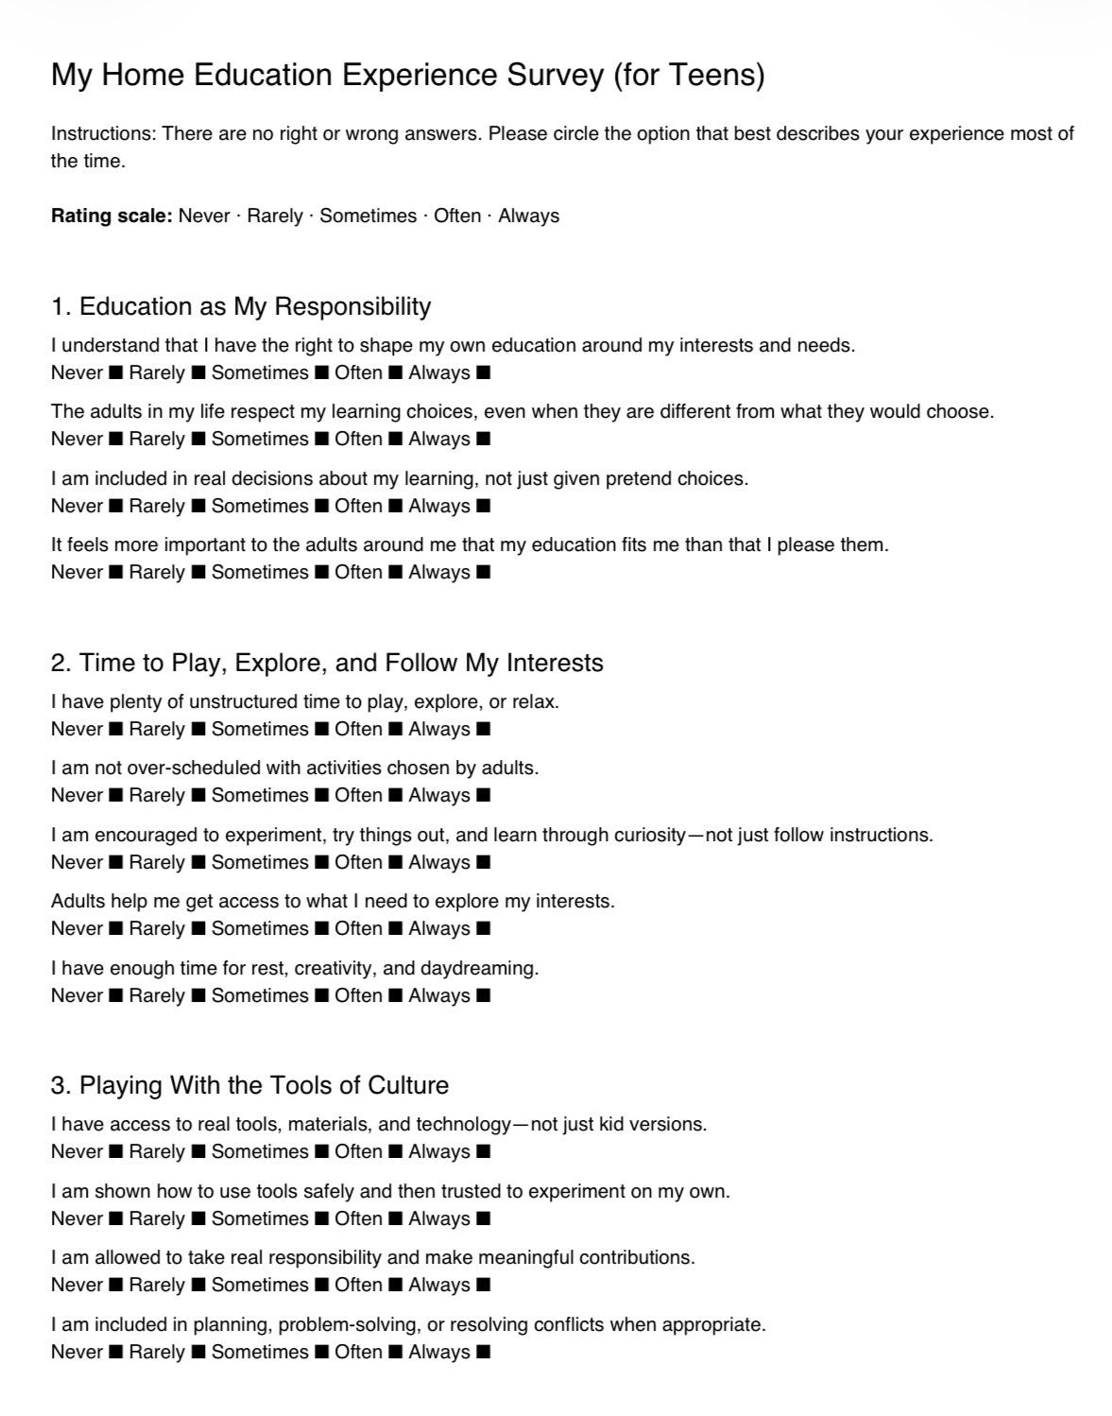
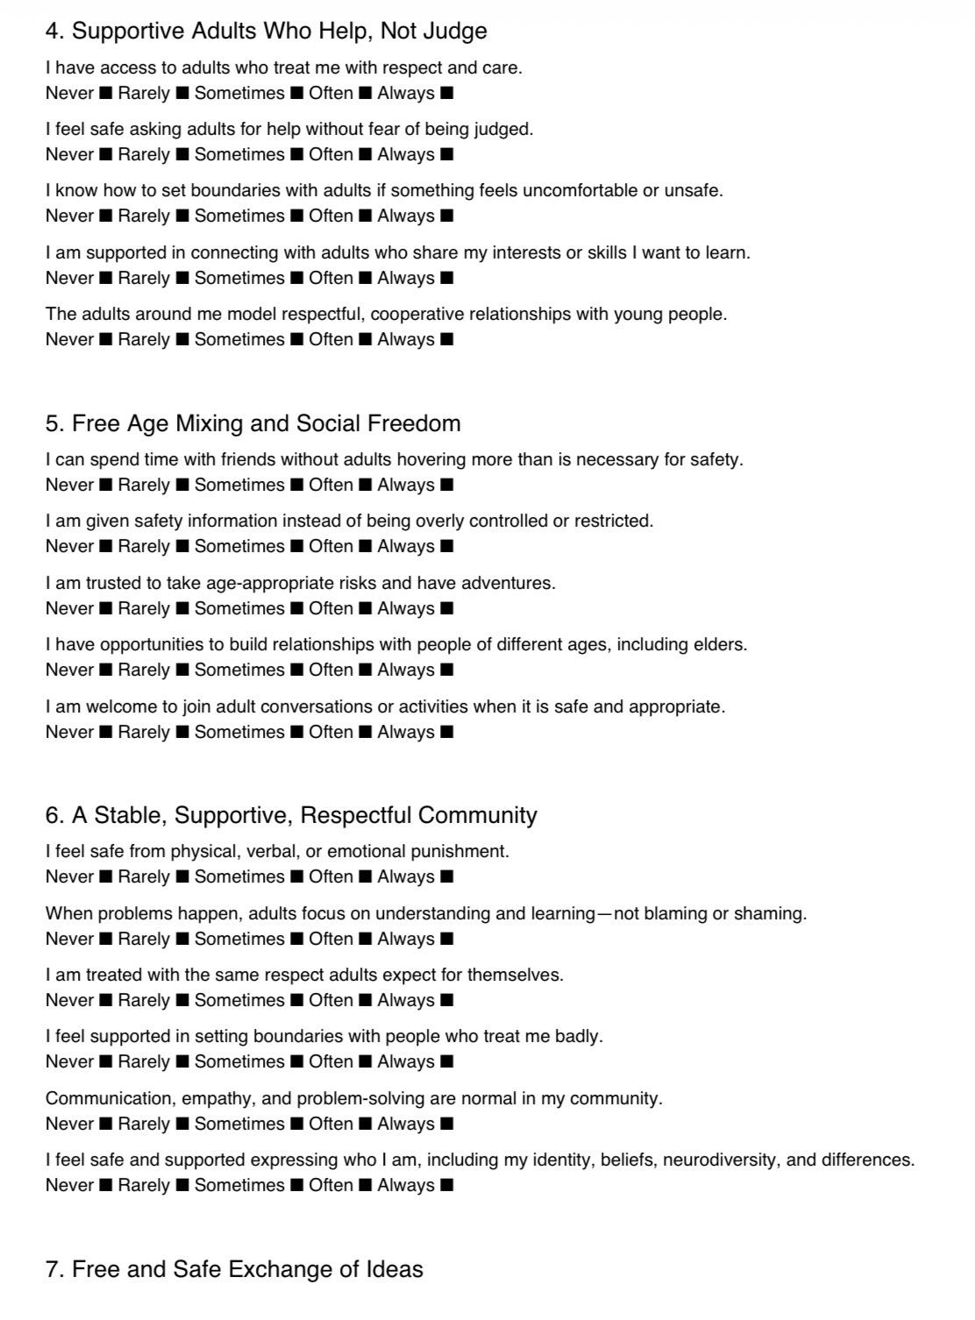
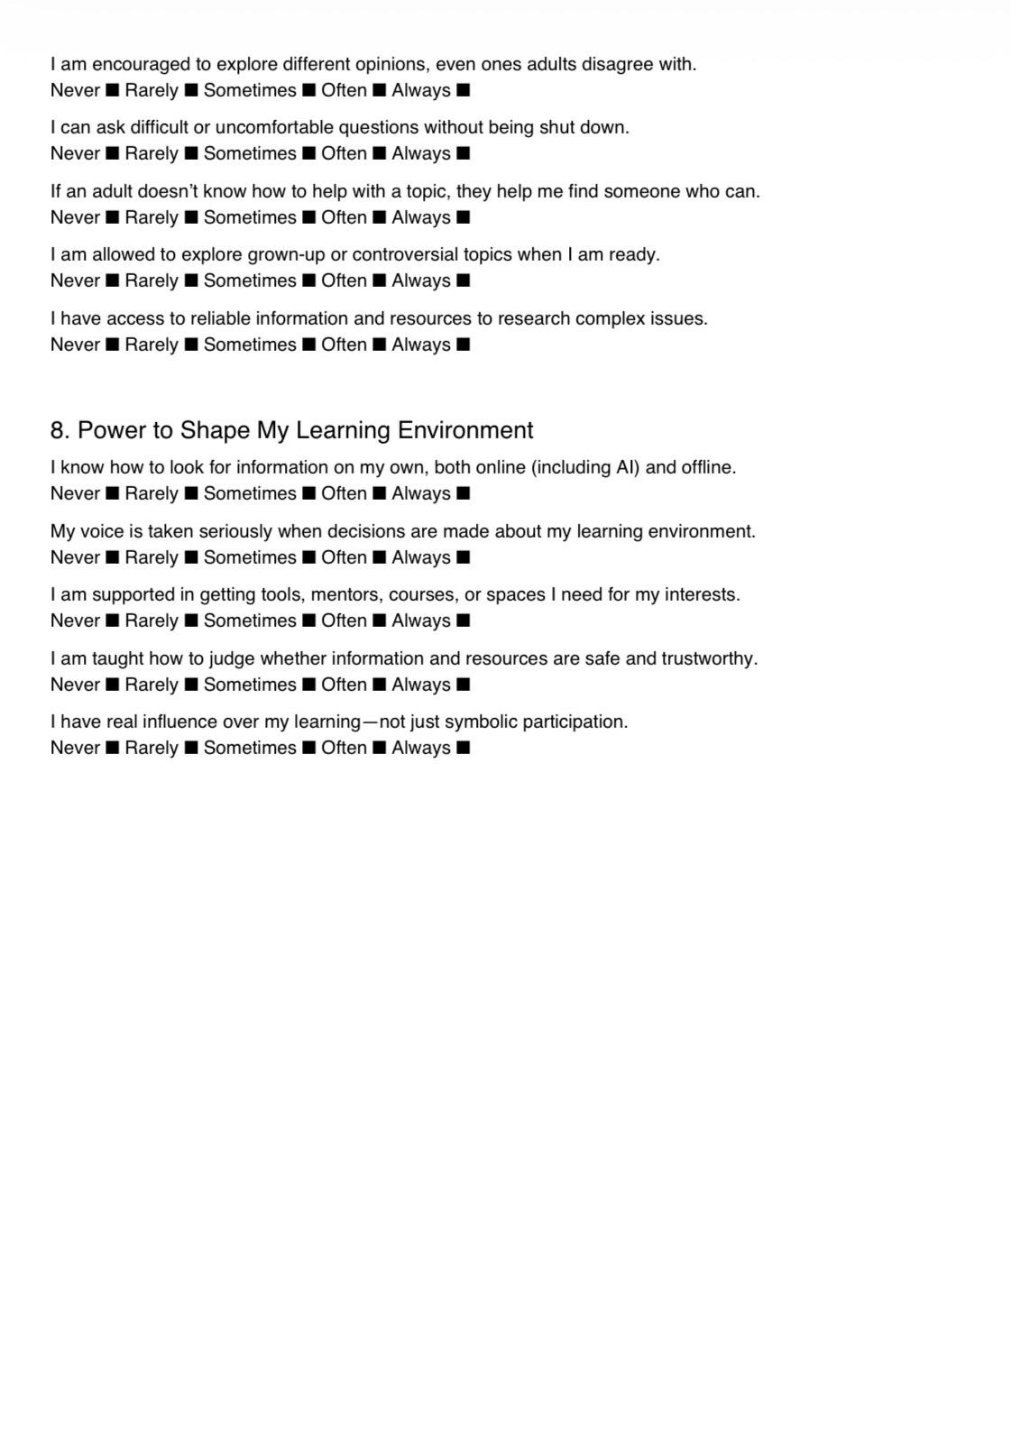


https://www.self-directed.org/
https://youtu.be/WYjkIIMmhcs?si=TyAXLJrIao82nhIy
https://eudec.org/2025/02/10/20-time-for-schools-a-modest-proposal-from-derry-hannam/
http://operi.ca/?page_id=137
http://operi.ca/
https://www.self-directed.org/resource/helping-the-butterfly-hatch-sde-facilitation-skills-development/
https://www.udemy.com/course/horizontal-communication/

