Mandate of the Special Rapporteur on the right to education

CURRICULUM, PEDAGOGY AND ASSESSMENT IN THE SERVICE OF THE RIGHT TO EDUCATION
Call for CONTRIBUTIONS

25 November 2025

Name of the country/entity submitting the information | ALLI asbl (Luxembourg)

Questions (please feel free to answer those that are most relevant to your work)
Please provide examples of national legislation and policies governing programmes, pedagogy and assessment at all levels of education, in both the public and private sectors, but particularly at the level of compulsory education.
Introduction
The current limitations of education systems are widely recognised: excessive standardisation, assessment pressure, loss of meaning, academic suffering, persistent inequalities. These findings are known to governments, international institutions and education professionals. The central question is therefore no longer what is not working, but what needs to be changed in concrete terms to bring educational practices into line with human rights ethics.
Based on the responses to the questions in the call for contributions and the field experience of ALLI asbl, this contribution formulates operational guidelines based on a guiding principle: the right to education cannot be realised without a profound transformation of the vision of childhood, learning and educational power.
- Design, development and implementation of school curricula:
  - To what extent is the school curriculum organised around requirements aimed, on the one hand, at ensuring learning needs and the acquisition of knowledge, particularly in order to meet contemporary challenges, and, on the other hand, at guaranteeing the acquisition of skills and know-how? What are the challenges to be addressed?

Observation
We need to question the assumption, derived from the dominant educational ideology, that a curriculum is a necessary condition for genuine learning. Far from being neutral, this prescriptive framework raises questions about its real ability to promote the effective acquisition of knowledge and, by restricting the learner's autonomy and free will, may hinder the development of skills that are nevertheless constitutive of human dignity.

Analysis
Respect for dignity begins with respect for free will.
"A child's stubbornness and indiscipline have as much right to be respected as their desire to learn. We must also encourage this natural force of will: opposition. If children do not learn to become self-aware, they will not learn the most important thing."
Observation of learning pathways, such as the acquisition of reading skills outside strictly standardised school programmes , shows that alternative methods that respect the learner's free will in an environment conducive to their development, rich in interaction and authenticity, contribute effectively and in a more fulfilling way to the development of fundamental skills.
In this context, strengthening language skills among as many people as possible appears to be a key issue in addressing contemporary challenges, as it determines the ability to exercise critical thinking, to distinguish reliable information from unreliable information, and to assert legitimate claims within the democratic sphere.
Proposals
1. Change our view of childhood and recognise young people as competent subjects of law

- Explicitly recognise, in legal, curricular and institutional frameworks, children and young people as subjects of law capable of understanding, volition and participation, and not as objects of training or correction.
- Abandon approaches based on deficit, immaturity or standardisation of trajectories in favour of progressive self-determination, in accordance with Article 12 of the CRC.
- Cease to use the protection of vulnerability as a justification for excessive domination or control.

Promote educational practices based on mutualism, cooperation and reciprocal recognition, in particular through multi-age group learning and diverse interactions with adults, enabling socialisation based on shared responsibility rather than hierarchy.

2. Rethink the curriculum: move from a prescriptive framework to an open learning environment
- Transform school curricula into open, flexible and multidisciplinary frameworks that enable learners to apply their knowledge to real-life issues they encounter in their lives.
- Reduce the weight of normative expectations by age or cycle, which produce effects of hierarchisation, exclusion and loss of meaning.
- Institutionally recognise informal, non-formal and self-directed learning as an integral part of the right to education.
- Guarantee free and unrestricted access to culture, educational resources and symbolic tools , which is essential for the natural development of fundamental learning.
The curriculum must cease to be an instrument of conformity and become exclusively a facilitation tool.

Justification
The ability of a school curriculum to respond to contemporary challenges cannot be separated from its contribution to building the learner's inherent sense of dignity. This sense can only develop if the person is recognised and accepted from an early age for who they are, rather than being shaped primarily by external, utilitarian or economic objectives. An education system that seeks primarily to train individuals to fit into a logic of performance, competitiveness or employability risks objectifying the student and conditioning their value to their usefulness.

Conversely, programmes that allow everyone the space to exist, discover themselves and develop at their own pace enable individuals to become aware of their intrinsic value. This awareness is the foundation for recognising the dignity of others and developing autonomy, critical thinking and resilience, which are essential conditions for free and responsible participation in social and democratic life.
This paradigm shift is a prerequisite for any effective alignment of educational policies and teaching practices with the principle of human dignity, as enshrined in international human rights law.
- How does the curriculum incorporate intercultural understanding, local languages, local knowledge and parallel knowledge systems?
- Are there restrictions on specific subjects? If so, please explain why.
Observation
Although we are not aware of any specific restrictions in Luxembourg, this question brings to mind a rather telling example of a misleading message in a neighbouring country.
In 2025, in France, at the Cité des enfants in Paris, on a sign informing children about their rights, the following text could be read by children about their right to equality:
"You have the right to be treated equally with other children. ...
Whoever you are, you have the same rights."
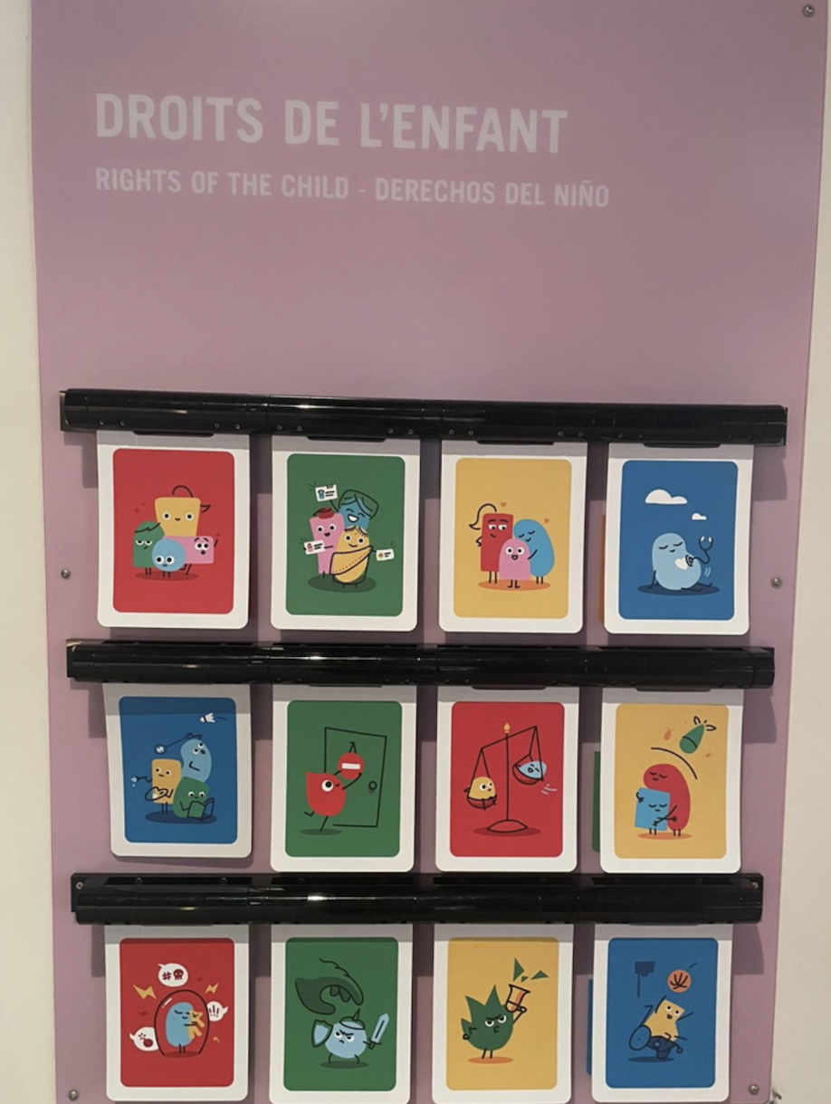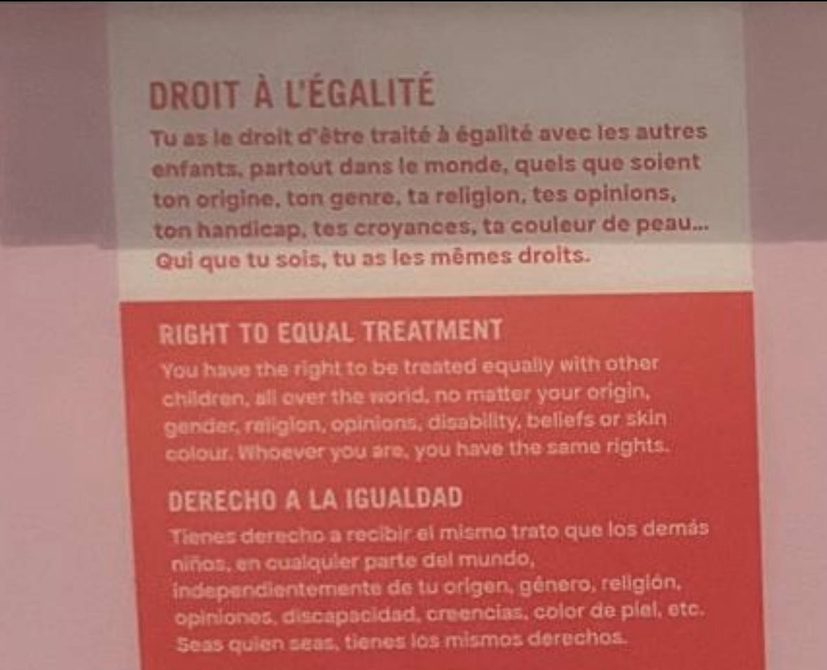

Analysis
Beyond presumed good intentions, what can be said about this wording in terms of fundamental rights?

Article 1 of the Universal Declaration of Human Rights proclaims that "all human beings are born free and equal in dignity and rights". This fundamental requirement of equality is reinforced at European level by Article 21 of the Charter of Fundamental Rights of the European Union, which expressly prohibits any discrimination based in particular on age, and by Article 14 of the European Convention on Human Rights, which prohibits any discrimination, including that based on situations not expressly listed, such as age.
Therefore, stating that minors have "the right to be treated equally with other children" or that "whoever you are, you have the same rights" remains insufficient if this equality is understood only within the group of children.
Proposal
With this in mind, we propose the introduction of a fundamental rights label applicable to school textbooks (or any other publication), awarded following an independent assessment of their compliance with the ethical and legal principles of fundamental rights, carried out by a specialised committee.
Such a label would help to ensure that educational content fully respects the equal dignity of all people and promotes education based on universal human rights values.

Justification
It is frequently observed, in general, that certain school textbooks use biased, reductive or prescriptive language that may convey representations contrary to the ethical principles guiding fundamental rights.
However, language should not be used as a tool for propaganda or ideological influence that undermines the fundamental values enshrined in international law, foremost among which is human dignity, the cornerstone of all treaties relating to fundamental rights.
Under the principle of equal dignity, minors have the right to be treated equally with everyone, regardless of age. Dignity applies to all. All human beings – children and adults alike – have the same value and dignity, which requires a respectful and egalitarian attitude in relationships, without renouncing the guiding role of those responsible for their protection, whether parents or others, taking each person's needs and personality seriously, while setting limits for mutual recognition and acting authentically. It is a matter of recognising that young people are individuals with feelings, thoughts, aspirations and wishes that are just as important as those of adults, which leads to greater trust and better quality relationships.

While their vulnerability may justify specific protective measures, these should not be used as a basis for establishing a hierarchy of dignity, nor should they legitimise relationships of domination or unjustified restrictions on their fundamental rights.

- Is the process of designing and approving the curriculum flexible and adaptable? Are emerging challenges or societal changes taken into account in curriculum revisions? If so, how? If not, what are the challenges?
- Which stakeholders are involved in decision-making regarding the curriculum? Do the scientific community, teachers, students, parents and local communities have the opportunity to participate in a meaningful way? What safeguards are in place to prevent undue influence or conflicts of interest in curriculum development and content selection, including by the private sector? Please provide concrete examples.
- Teaching and learning in the classroom:
  - What teaching approaches are officially required or encouraged, and how do these align with human rights objectives such as inclusion, participation, dignity, non-discrimination and learner-centred education?
Proposal

Transforming the teaching relationship: moving from control to facilitation
- Redefining the role of the teacher as a facilitator, mediator and guarantor of a safe environment, rather than as the sole holder of normative authority.
- Promote educational environments based on trust, cooperation, experimentation and the right to make mistakes.
- Enable and recognise non-directive teaching practices focused on intrinsic motivation, when they effectively contribute to the development of skills and autonomy.
An educational relationship that respects human dignity is based on mutual recognition and the possibility of self-assertion, not on obedience.

  - How is pedagogical freedom in teaching guaranteed ? Are there mechanisms for dialogue and feedback from pupils and parents to meaningfully shape teaching practices, without undue interference?

Ensuring genuine educational freedom
Proposal:
- Separate pedagogical freedom from the obligation to strictly comply with single academic standards.
- Provide legal protection for teachers who implement alternative practices that are fully aligned with the objectives of the right to education.
- End teacher inspection and evaluation systems that discourage innovation and reinforce standardisation.
There can be no real pedagogical freedom as long as expectations remain primarily defined by academic conformity.
  - How can effective alternative pedagogical models, developed in certain public or private schools, be integrated into the traditional education system?
  - How are teachers trained and supported to initiate and implement learner-centred, inclusive and participatory pedagogies, and what factors limit their ability to do so? Please also describe professional development, mentoring systems, resources and training on social-emotional learning, mental health and wellbeing, trauma-informed approaches and inclusive education (i.e. reflecting the full diversity of learners).
Observation
According to some teachers, what often limits their ability to act is a lack of understanding of unconventional practices by their colleagues, who then exert a certain amount of social pressure, and insufficient support from the institution.

Proposal
Support teachers in systemic transformation
- Reform initial and continuing teacher training to incorporate a thorough understanding of human rights, participation, self-determination and learner-centred pedagogies.
- Institutionally recognise teachers who explore alternative educational approaches that are fully aligned with fundamental rights but unconventional, and provide them with explicit support.
- Break with the logic of social and hierarchical pressure that prevents teachers from thinking outside the box.
Transforming educational practices requires institutional courage, not just individual commitment.
Establishment of a collaborative platform:
- 🌐 Mutual support forum for 'innovative' teachers
- 📚 Library of shared and tested resources
- ⚖️ Legal advice to protect alternative practices
- 👥 Mentoring by experienced teachers
Analysis
Thinking outside the box and acting differently therefore requires a strong personality and a great deal of courage and resilience, which are more difficult to acquire in an education system based on obedience.
In certain contexts, conventional educational practices tend to reproduce existing asymmetrical power relations and patterns of domination, rather than equipping learners with the tools they need to identify, understand and critically question them.
By implicitly promoting models of success based on performance, competitiveness and adaptability to market demands, these practices can contribute to establishing certain personality and behavioural profiles as norms to be emulated, to the benefit of already dominant economic and social interests. In doing so, they risk perpetuating social inequalities by legitimising the existing economic order and limiting learners' perception of the existence of alternatives that are fairer, more equitable and more respectful of human dignity.
Justification
The experience of Derry Hannam, a teacher who became an inspector in a state school, shows that when teaching is learner-centred and conducted in a democratic manner, many problems are mitigated and results improve. These practices deserve to be recognised and valued by public authorities. Teachers need to know that they can safely explore new approaches in this direction and feel justified in doing so.
Je'anna L. Clements' works, Helping the Butterfly Hatch (volumes 1 and 2), which we have also translated into French but not yet published, offer an empirical conceptualisation of the implementation of learner-centred, inclusive and participatory pedagogy.

There is ample empirical evidence supporting these autonomous educational approaches and their positive side effects on mental health, civic engagement and lifelong fulfilment.

A brief aside
To address the lack of awareness of fundamental rights, our association has designed an educational guide to help people understand the human rights ecosystem and encourage them to think about their power to act to activate them. It will be presented at the Learning Planet Festival and will be freely available online in English, French and German in 2026.

For more information on the FutureEd project, please visit:
https://alliasbl.lu/fr/2025/12/10/%f0%9f%8c%8d-futureed-learning-planet-festival-janvier-2026/ or by scanning the following QR code.
 | Three online sessions to rethink education through human rights  As part of the FutureEd project, co-funded by the European Union, ALLI asbl invites you to three inspiring meetings during the Learning Planet Festival 2026 on the theme of "Caring for yourself, others and the planet". Together, let's explore how rights-based education can contribute to a more sustainable future.

  - Are there any discrepancies between the official curriculum and actual classroom practice? If so, what are the reasons for this?
- Student assessment:
  - How are assessment systems aligned with educational objectives as defined in international human rights law? Please describe the balance between holistic, formative and flexible approaches and more standardised or high-stakes assessments.
  - To what extent do current assessment practices protect against discrimination, excessive standardisation and cultural assimilation? Please provide examples of measures taken to ensure equity for learners facing linguistic, socio-economic, disability or geographical barriers. Do you have examples of local, culturally rooted or community-developed approaches to defining and assessing learning success?

Observation
We observe that current assessment practices hinder educational pluralism and stifle innovation by tending to impose what can be easily assessed according to a set of standardised criteria.
Proposal
- Recognise the legitimacy of alternative educational models, including those outside the conventional school system, when they comply with the objectives of education as defined in international human rights law.
- Ensure equitable access to educational resources regardless of the mode of instruction.
- Cease imposing compliance requirements modelled on the school system on practices that do not conform to school standards but are consistent with fundamental rights.
Educational pluralism is not a threat to the right to education, but one of its conditions.

Analysis
By imposing assessment practices based on standardised academic benchmarks that are unsuited to alternative teaching methods, which favour more autonomous, contextual and non-linear approaches, the education system tends to produce indirectly discriminatory effects. The learning outcomes of these pedagogies cannot be measured exclusively in quantitative terms or according to a uniform progression, which leads to a systemic devaluation of skills that are nevertheless real.
This mechanism is reminiscent of the historical treatment of certain Roma children who, having not previously attended school and not having acquired the dominant academic codes, were directed towards classes dedicated to "students with mental disabilities" or specialised education. Such placement, based on an assessment of their inadequacy to pre-established academic standards rather than their actual abilities, constituted a form of structural discrimination that was stigmatising and contrary to the principle of equal dignity.
In both cases, assessment becomes a tool for standardisation and selection rather than an instrument for personal emancipation and development. It confuses differences in background with disability, and educational diversity with cognitive insufficiency. These practices not only hinder the plurality of pedagogical approaches, but also the essential educational paradigm shift required to meet contemporary challenges, in violation of the objectives of education as defined by international human rights law, in particular respect for dignity, non-discrimination and the full development of the personality.
(See our opinion of 27 September 2025 on Bill 8588: https://alliasbl.lu/fr/publications/)
Justification
We believe that the educational approaches promoted by the Council of Europe's Reference Framework of Competences for Democratic Culture (CRCCD) are more promising. They favour qualitative, formative and contextualised forms of assessment, valuing not only academic knowledge but also the social, civic and intercultural skills essential for democratic participation.
Finally, these participatory and inclusive approaches contribute directly to the achievement of fundamental human rights objectives: to educate autonomous individuals who are capable of critical thinking, respectful of otherness and able to engage responsibly in social and democratic life. They thus reflect a conception of education as a lever for emancipation, rather than a mere tool for conformity, which is fully consistent with the State's international human rights commitments.
Ultimately, learning cannot be reduced to a formal obligation or conformity to pre-established standards: it must be cultivated as a pleasure, a personal and lasting endeavour. It is by enabling everyone to identify their needs, understand their learning style and make it a reflective and autonomous process that education can fully fulfil its vocation: to support lifelong learning, while respecting dignity, diversity of backgrounds and the freedom to develop oneself.

  - How do assessment practices promote dignity, motivation and well-being for all learners and educators? Are there pressures, unintended consequences or forms of stress associated with examinations or inspection regimes?

Proposal
Reconfiguring assessment: preserving dignity and supporting learning
- Strictly limit standardised, high-stakes assessments to situations where they are essential, particularly for reasons external to the educational process, such as validating the skills required for certain professions.
- Replace ranking and judgement with formative, qualitative, contextualised and consensual assessments.
- Recognise and generalise alternative assessment methods: portfolios, projects, self-assessment, peer assessment, learning narratives.
- Ensure that all assessments explicitly focus on learning and understanding, rather than selection or stigmatisation.
Assessment that undermines dignity is incompatible with the right to education.
  - How is teacher autonomy supported in the area of assessment, and can teachers use alternative assessment models, such as portfolios, project-based assessments, performance tasks, learning exhibitions, self-assessment or peer assessment? Are teachers allowed to adapt assessment methods to the diverse needs of learners?
  - Are school budgets linked to student performance? If so, to what extent and what safeguards are in place to avoid undue pressure from school rankings, commercial tests or external actors?
  - How do assessment systems recognise socio-emotional learning, creativity, cooperation, problem solving and other skills that are difficult to capture through standardised tests? Please provide examples where these skills are assessed in a meaningful way.

Conclusion
Aligning educational practices with human rights ethics requires much more than technical adjustments. It requires a conscious break with a vision of childhood (and life) based on control, standardisation and hierarchy. The legal frameworks already exist. What is lacking are clear political choices to transform practices, redistribute educational power and fully recognise the dignity, autonomy and capacity for meaning of children and young people.

https://jlupub.ub.uni-giessen.de/items/52fd08fc-6405-4406-82fb-a1479adc1614
https://www.education-authentique.org/uploads/PDF-DOC/SED_Deleducation_Stirner.pdf
See our opinion on reading instruction dated 20 January 2023 following Bill 7977 https://alliasbl.lu/fr/publications/
Symbolic tools are systems that enable us to think about, represent and communicate the world without directly resorting to physical action. Classic examples include language, writing, numbers, mathematical symbols, diagrams, maps, codes and certain cultural conventions.
https://lehetremyriadis.fr/boutique/livres/parentalite-education/profs-une-autre-voie-est-possible-derry-hannam/
https://www.paagman.nl/product/77179483/helping-the-butterfly-hatch-book-two-how-can-we-support-young-people-in-self-directed-education--door-jeanna-l-clements
The text by researcher Marie-Noëlle Chamoux is inspiring in this regard. https://www.researchgate.net/publication/32223244_Apprendre_autrement https://www.education-authentique.org/uploads/PDF-DOC/CIN_Indiens_Nahuas_Chamoux.pdf

