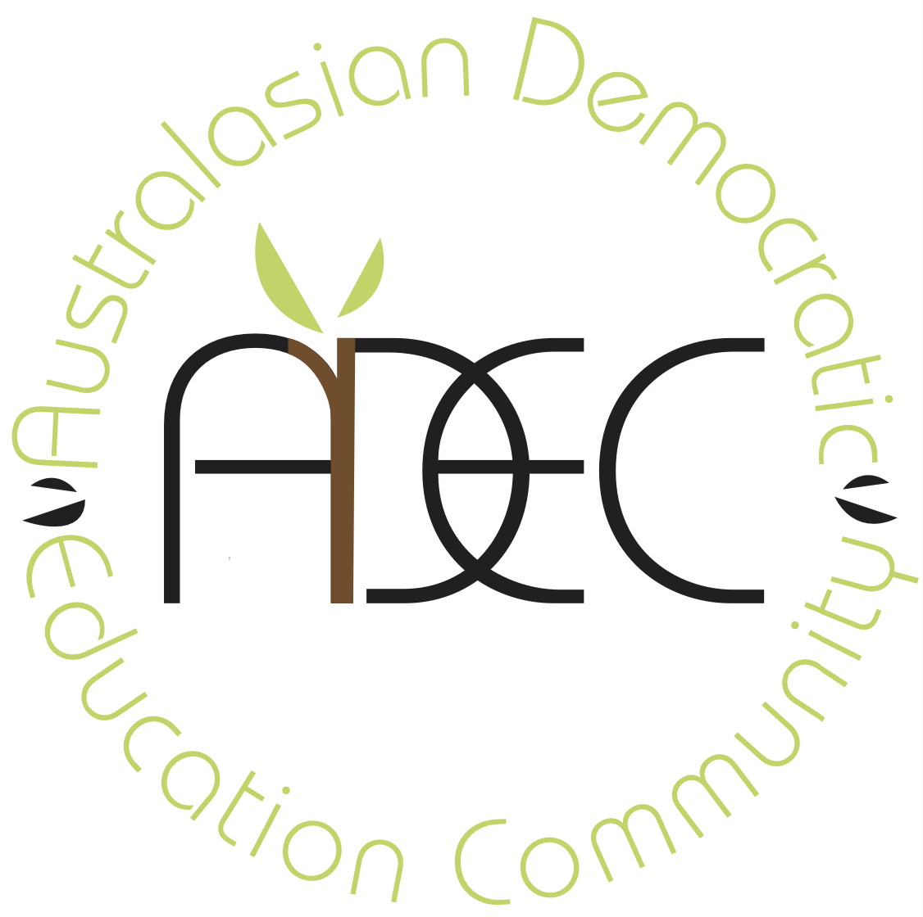
23 January 2026
Call for inputs: Curriculum, pedagogy and assessment at the service of the right to education

The Australasian Democratic Education Community (ADEC) is a registered not-for-profit incorporated association that supports member schools and individual learners of all ages across Australia and Aotearoa New Zealand who are interested and involved in democratic, progressive, and alternative education. We support participatory, democratic decision-making in education, and promote self-direction, self-regulation, conflict resolution, lifelong learning, and cooperation rather than competition.

The opening statement of the call for inputs from the UN Special Rapporteur on the Right to Education states that she will consider curriculum, pedagogy and assessment at the service of the right to education. Curriculum, pedagogy and assessment together define the substantive content of the right to education.

The members of ADEC question the implied status and core role these concepts play in genuine child-centred and democratic learning. While we agree that curriculum (what is taught), pedagogy (how it is taught) and assessment (observing what is learned and understood) are important categories in education, we seek a broader definition for these terms to encompass multiple ways of teaching, learning and relating. In both national and global contexts, limiting the scope of these terms privileges certain ways of operating in education that we believe negatively affect teachers, children and families. Throughout our report, we expand on how these definitions need to be widened to be more inclusive, agentic, and to enhance learning opportunities for all young people.
We agree wholeheartedly with the stated aim that “Education must foster the full development of the human personality and a sense of dignity, strengthen respect for human rights and fundamental freedoms and equip every person to participate effectively in a free society.” (Article 26 of the Universal Declaration of Human Rights; Article 13 of the International Covenant on Economic, Social and Cultural Rights (ICESCR); Article 29 of the Convention on the Rights of the Child (CRC)). Democratic education supports these aims by enabling autonomy and agency for teachers, students and families. At its core, the philosophical basis of education must include these stakeholders in meaningful ways.
ADEC also notes that the right to education is frequently understood through the “4As” framework: education must be Available, Accessible, Acceptable, and Adaptable. Democratic education particularly strengthens the acceptability and adaptability of education by ensuring learning is meaningful, culturally responsive, dignity-affirming, and relevant to the lived experiences of children and young people. By centering participation, agency, and shared decision-making, democratic approaches help education remain responsive to diverse learners and communities, rather than enforcing a one-size-fits-all model.
In the sections that follow, we outline how democratic education reframes curriculum, pedagogy and assessment in ways that strengthen children’s rights and educational equity.

Curriculum
In discussing curriculum, we acknowledge that it has both a visible and an “unseen” aspect—in other words, it contains what is taught explicitly (as content) and implicitly (as ethos). We believe that both of these aspects must be in service of the right to education as defined in Article 29 of the CRC.
ADEC’s philosophical view of curriculum includes everything that happens in a school space, including the fundamental relationships between learners and the broader community context. We view all participants in the space as capable of learning from each other without hierarchy. In this way, curriculum is more than a narrow view of a document prescribing learning outcomes; it is an expansive and contextual view of what is happening in an educational setting.
Curriculum content is often spontaneously generated (by students, teachers or family members) in response to an activity or inquiry that a student, or group of students, has chosen to engage in (this often occurs in free play). Curriculum planning is responsive to student interests and needs. In addition, the relational nature of learning in a democratic context provides rich opportunities for emotional intelligence learning, and the self-governing nature of our schools means that students learn to resolve conflicts and make decisions that take everyone’s needs into account. The values of cooperation, consensus and community are taught explicitly and implicitly.
ADEC also emphasises that play is not “extra” or optional in education. Play is central to how children explore, make meaning, build relationships, practise problem-solving, and develop self-regulation. It is also protected under Article 31 of the CRC, which recognises children’s right to rest, leisure, play and participation in cultural life and the arts. We believe education systems must ensure that curriculum, pedagogy and assessment do not unintentionally erode children’s right to play through excessive standardisation, compliance demands, or narrow definitions of “achievement”.
In Australia and Aotearoa New Zealand, within authoritarian, top-down models of control and bureaucracy, students are often expected to engage with pre-determined curriculum content that has been assigned to them by others, with limited contribution from teachers and students. Some students disengage when curriculum feels irrelevant to their lives, interests, culture, identity, or developmental readiness. Furthermore, students may experience schooling as primarily focused on competition and compliance, and those who cannot access this model are at greater risk of exclusion and educational failure. Hierarchical patterns can allow power over others to persist despite explicit curriculum content designed to prevent it. Many of these scenarios may block young people from effective participation in education and in “free society”, particularly those who are disadvantaged by structural inequality.
For schools based in community, democracy and agency (such as our member schools), curriculum is created and negotiated by young people and their educators in response to their contextualised needs, interests and lived experiences, with reference to national curriculum aims and goals. In practice, this may include prioritising play and discovery, student-led inquiry projects, negotiated learning plans, and community decision-making forums that shape what is explored and how learning is documented. Educators then map the learning evidence to required curriculum outcomes without undermining student agency. Learners are engaged in authentic learning and empowered to become fully self-managing and self-responsible. As a result, graduates tend to be engaged lifelong learners and active citizens.
In Australia and Aotearoa New Zealand, we have both state-based and/or national curricula which are mandated for registration and the conduct of all schools. This is a fundamental challenge for those of us in democratic schools, where our emphasis aligns with Article 12 of the Convention on the Rights of the Child (UNCRC), which states that the child is capable of forming their own views and has the right to express those views freely in all matters affecting them. Further, the fundamental premise of democratic schools is entwined with Articles 13 and 14 (UNCRC), which state that the child shall have the right to freedom of expression (including the freedom to seek, receive and impart information and ideas of all kinds) and the right to freedom of thought, conscience and religion.
The tension in balancing an agentic view of curriculum with mandated curriculum models can create considerable difficulties for our member schools, who are burdened with proving that the content they teach covers both mandated curriculum outcomes and students’ contextual needs and interests. In some instances, schools—particularly those working with marginalised groups and communities, including First Nations children—have faced serious regulatory consequences when they are unable to evidence these links to the satisfaction of education authorities. In these instances, we believe a bureaucratic model of government oversight can apply a narrow lens of curriculum that fails to take into account children’s rights under the UNCRC and their right to a quality education.
Article 26 of the Universal Declaration of Human Rights (1948) states that everyone has the right to education. Further, Article 26(3) states that parents have a prior right to choose the kind of education that shall be given to their children. We believe that by asserting parental rights to choose democratic education for their young people, governments should support access to schools of choice, diversity and difference in curriculum models. More awareness must be given to the ways in which curriculum can be viewed democratically, taking young people’s views, experiences and contextual needs into account.
In this context, it is worth acknowledging the positive impact of the Ardern Labour government in Aotearoa New Zealand (2017–2023) on children’s right to a quality education. In an effort to improve educational outcomes for Māori, it legislated a requirement for all schools to give effect to Te Tiriti o Waitangi (which grants Indigenous Māori the right to their language and ways of learning and being), and it offered schools financial and training support for localised curriculum creation to help them implement this. This created excitement and interest in decolonised and democratic forms of curriculum across the sector. The current government has removed both of these improvements as part of their ongoing effort to de-indigenise the national curriculum in favour of “knowledge rich” governmentally prescribed content (Moss, 2025), which increases pressure on Māori immersion schools and democratic schools in Aotearoa New Zealand.

Pedagogy
Equally, we believe children’s rights to a quality education must include pedagogical autonomy for teachers. Teachers need access to quality training that provides them with continual information for improved practices, but also autonomy in their professional choices. When we de-professionalise teachers’ autonomy and ability to make pedagogical decisions, we reduce their capacity to make curriculum meaningful to individual learners. We also reduce students’ meaningful inclusion, negotiation and participation in their learning.
An example of this is the current explicit teaching agenda in Australian and Aotearoa New Zealand schools (and globally). This mandating has created a tension many of us feel: the difference between evidence-informed practice (which draws on research while leaving space for teacher judgment, child context, and professional creativity) and the version of evidence-based practice that can come across as narrow, rigid, or dismissive of other approaches.

For example, one major literacy program states: “the approach we take is non-categorical, which means that we do not focus on the underlying causes or reasons why a child may have failed to make progress in reading. Those labels have not been found to be useful in determining how a child can best be helped to learn.” (Multilit, “Our Approach”, https://multilit.com/)
In Aotearoa New Zealand, this thinking is echoed by the current government’s approach to structured literacy implementation across Aotearoa New Zealand schools, in which they removed readers that include everyday Māori words, despite evidence that such readers support Indigenous students to learn to read and do not hamper the effectiveness of the structured approach. (Yelland et al., 1993; Göncz & Kodžopeljić, 1991; et al. in Gillon, 2024)
Teaching literacy effectively matters enormously, but if the broader social, emotional, and economic conditions shaping children’s lives are sidelined, we risk placing the entire burden of learning outcomes on instructional methods alone. These examples show exactly where this tension sits: if we do not attend to causes and contexts, we risk offering technical “fixes” without addressing structural inequities. Additionally, evidence-informed practice must include play-based and inquiry-rich approaches, particularly in early childhood and primary years, where play is a key driver of language, social development, creativity and executive functioning.
Decades of reading research cautions that privileging one set of tools can inhibit our ability to differentiate instruction for individuals (Compton-Lilly et al., 2023; Gawne, 2024; Watson & Wildy, 2014; Wyse & Bradbury, 2022). Further, research such as the Strathclyde 3 Domain Model emphasises the integral nature of context (personal and social capital) and identity (agency as a learner), as well as the cognitive, in addressing literacy instruction from social justice, inclusion and achievement perspectives (Ellis & Rowe, 2020; Ellis, 2020). This is reinforced by a recent OECD report into curriculum autonomy and flexibility, which outlined how essential student agency, co-agency and wellbeing are in achieving educational outcomes (OECD, 2024).
These voices emphasise teacher professionalism, in which educators have a toolkit of pedagogical strategies to draw on that includes, but is not limited to, explicit teaching. They emphasise that a “one-size-fits-all” model is dangerously inadequate in addressing the complexities of human learning and the individual needs of learners and communities. However, these voices are increasingly marginalised by pressure for universally applied solutions.
ADEC and its member schools stand firm in the belief that the right to education includes equipping teachers with quality pedagogical practices and knowledge, and making space for autonomy and agency with regard to pedagogical decisions.

Assessment
In Australia and Aotearoa New Zealand, there have been more than twenty-five years of various iterations of mandated, standardised testing, and very little appetite to consider a different approach despite the reality that “standards” have fallen and the equity gap has widened. The pressure on students, teachers and schools to perform does not support the dignity, motivation and wellbeing of all learners and educators. (Assessment Question c of Special Rapporteur’s Questionnaire, n.d.)
We value the right of parents to decide if their children participate in these events. We also call for the right of students, teachers and schools to decide whether they find educational value in participating in high-stakes testing. We also call for the rights of students to design their own assessment, and to be given transparency and a role in the assessment process.
Assessment needs to be for learning. When it is contextual and meaningful, it does not need to be stressful. It should be purposeful and diverse, serving further learning rather than punishing difference. Nor is there value in judging the quality of teachers or linking pay and conditions to test results.
When assessment derives from a deficit way of perceiving learning, it drives negative judgement and many young people—and teachers as well—come to think of themselves as failures. Despite pleas not to use this personal data, some media are complicit in adding to distress and false narratives by ranking schools, encouraging competition, and pressuring governments to do more of the same. This can also have flow-on effects to curriculum and pedagogy as schools feel pressured to comply with techniques that focus on testing results rather than best practice for longer-term learning, growth and development.
We urge governments to recognise multiple valid forms of evidence of learning—portfolios, exhibitions, project work, narrative reporting and self/peer assessment—alongside or instead of high-stakes standardised testing.
In Australia, mandatory five-point scale reporting also exists, which forces schools to use grading against standards that compare and rank students. Our organisation would argue that mandatory five-point scale reporting is further evidence of a “one-size” approach to education. In Australia, a differing system of reporting (the competency framework of Vocational Education and Training (VET)) exists for students undertaking VET studies in senior schooling and beyond. We argue that this demonstrates that a different assessment system is possible, and we call for governments and systems to allow multiple ways of assessing competencies and achievements to be recognised in schools. This would provide greater autonomy, agency and flexibility to students, teachers and schools to use the best tool that is fit for purpose, respecting the input of their students, families and communities.

AI and its role in Curriculum, Pedagogy and Assessment
More and more, the reality and role of AI and human interaction in education is a keenly contested space in our schools. There is a need for balance and a need to critically examine the role of teachers, education and AI in the lives and learning of children. We need to carefully examine this world of AI and ask the same question of it: is it in service of the right to education?
AI can support learning, but it cannot replace human interaction and human connection. When we already de-humanise teachers by limiting their autonomy and professional decision-making in curriculum, pedagogy and assessment—giving them scripts they cannot deviate from—we further devalue human relationships and contribute to the teacher shortage crisis occurring globally. We also limit teachers’ joy in their work.
We owe it to our children to engage with them to become literate citizens in the AI worlds of their futures, but not at the expense of their humanity.

Conclusion
We applaud and appreciate the role of the Special Rapporteur in taking the time to focus on these key issues in education, and for hearing submissions from across the globe, including those of us (such as ADEC member schools) who are working with a democratic philosophical base.

We believe that it is imperative for global education to include a strong democratic focus. Education for peace and understanding must include a strong focus on equipping young people with the skills for conflict transformation and peace education. Students must be actively supported to engage in mediation, activism and agency rather than passive recipients of rules and agendas. Democratic education in our schools promotes problem-solving, conflict resolution and transformation skills, including frameworks such as Non-Violent Communication, Restorative Justice, and peace education.
Further, we believe that “you can’t be what you can’t see.” In order to raise active democratic citizens who feel skilled, empowered and comfortable making decisions and taking agency in their own lives, schools need to encourage this from childhood. Students in our spaces are encouraged to be active participants in the culture and community of their societies, not just as future citizens but as current citizens with rights, ideas and opinions. We encourage recognition of the important role democratic education plays in the educational landscape, both now and into the future.

Recommendations
To ensure curriculum, pedagogy and assessment are genuinely in service of the right to education, ADEC urges education systems to:
- Recognise democratic governance and student participation as legitimate, rights-aligned approaches to learner-centred education, consistent with the UNCRC.
- Reduce reliance on high-stakes standardised testing and avoid punitive accountability measures that undermine dignity, wellbeing, equity and meaningful learning.
- Enable flexible, context-responsive assessment and reporting models, including portfolios, exhibitions of learning, project-based assessments, narrative reporting, and self/peer assessment.
- Protect teacher professional autonomy to make pedagogical decisions that respond to diverse learners, cultural contexts and local community needs.
- Support localised curriculum creation through meaningful participation of learners, families and communities, consistent with the UNCRC.
- Protect children’s right to play (CRC Article 31) by ensuring curriculum, pedagogy and assessment frameworks allow time and space for play-based learning, creativity, and exploration across schooling.

References
Compton-Lilly, C., Spence, L., Thomas, P., & Decker, S. (2023). Stories grounded in decades of research: What we truly know about the teaching of reading. The Reading Teacher, 77(3), 392–400. https://doi.org/10.1002/trtr.225
Ellis, S. (2020). The Strathclyde 3 Domain Model: Rethinking the pedagogic process. PETAA. https://petaa.edu.au/w/Professional_Learning/webinar-pages/Sue-Ellis-18FEB20.aspx
Ellis, S., & Rowe, A. (2020). Literacy, social justice and inclusion: A large-scale design experiment to narrow the attainment gap linked to poverty. Support for Learning, 35(4), 418–439. https://doi.org/10.1111/1467-9604.12324
Gawne, E. (2024). The politics and pedagogy of teaching literacy in the state of Victoria, Australia. Educational Research for Policy and Practice. https://doi.org/10.1007/s10671-024-09390-7
Gillon, G. (2024). Discussion paper on advice provided to the Minister of Education in October 2024: The use of kupu Māori in the Ready to Read Phonics Plus Readers. Maramatanga. https://maramatanga.ac.nz/index.php/media/7350/download?inline
Moss, J. (2025). The imported ideology behind education reform. E-Tangata. https://e-tangata.co.nz/comment-and-analysis/the-imported-ideology-behind-education-reform/
Multilit. (n.d.). Our approach. https://multilit.com/
OECD. (2024). Curriculum flexibility and autonomy: Promoting a thriving learning environment. OECD Publishing. https://doi.org/10.1787/eccbbac2-en
Tomasevski, K. (2001). Human rights obligations: Making education available, accessible, acceptable and adaptable. Right to Education Primers No. 3.
United Nations. (1948). Universal Declaration of Human Rights (Article 26). https://www.un.org/en/about-us/universal-declaration-of-human-rights
United Nations. (1966). International Covenant on Economic, Social and Cultural Rights (Article 13). https://www.ohchr.org/en/instruments-mechanisms/instruments/international-covenant-economic-social-and-cultural-rights
United Nations. (1989). Convention on the Rights of the Child. https://www.ohchr.org/en/instruments-mechanisms/instruments/convention-rights-child
United Nations Human Rights Office of the High Commissioner. (n.d.). Questionnaire on education curriculum for the Special Rapporteur [Word document]. Office of the United Nations High Commissioner for Human Rights. https://view.officeapps.live.com/op/view.aspx?src=https%3A%2F%2Fwww.ohchr.org%2Fsites%2Fdefault%2Ffiles%2Fdocuments%2Fcfi-subm%2Fsr-edu-curriculum%2Fcpa-questionnaire-for-en.docx
Watson, R., & Wildy, H. (2014). Pedagogical practice of early childhood teachers: Explicit enhancement of students’ literacy. Australasian Journal of Early Childhood, 39(2), 82–90. https://doi.org/10.1177/18369391140390
Wyse, D., & Bradbury, A. (2022). Reading wars or reading reconciliation? A critical examination of robust research evidence, curriculum policy and teachers’ practices for teaching phonics and reading. Review of Education, 10, e3314. https://doi.org/10.1002/rev3.3314

